Using artificially created data

This linear regression project predicts how well a clothing store does online (website vs App) with the use of :



Output:



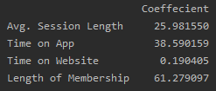

Concluded with the help of coefficients that their App does better than their website with data showing that

Website = $0.19 spent per unit of time spent on the website

App = $38.59 spent per unit of time spent on the App